Some Selected Research on Screen Time and Children:

- The American Academy of Pediatrics initially recommended no screen time at all for babies and toddlers under 2 years of age. However, parents resisted, and the recommendation has been softened. Most toddlers and preschoolers now spend two to five hours each day using screens—more time than they spend on books or free play.
- There is no such thing as “educational programming” for young children. Screen use disrupts sleep patterns, increases aggression, leads to obesity, affects speech development, and invites children (and parents) to be easily distracted and to lack focus. Including when they are multi-tasking, 8-18 year olds consume an average of 7 hours and 11 minutes of screen media per day – an increase of 2.5 hours in just 10 years.
- Screens in bedrooms have negative effects for all ages. Thirty-six percent of toddlers have a television in their bedroom. Adolescents with a screen in their bedroom spend more time engaging in screen time and report less physical activity, less healthy dietary habits, worse school performance, and fewer family meals.
- Screen time can be habit forming: the more time children engage with screens, the harder time they have turning them off as they become older children.
- All important early learning happens in the context of relationships. There simply is no substitute for time and connection. Academic success and the development of empathy are both linked to the number of “utterances” a child hears each day. When pre-teens spent 5 days at camp without any tech, empathy was restored which they had lost due to doing too much screen time.

Helping teens navigate life with screens:

- Create a healthy, balanced lifestyle for your family. You lead; your teens will follow. (See the “Healthy Mind Platter” created by Dr. Daniel Siegel)
- Create “tech-free zones.” For example, all screens should be off and put away during dinner, family activities, outdoor exercise, and at least one hour before bed.
- Put computers and TVs in family areas, not bedrooms.
- Talk with your teens often about games, the Internet, apps, pornography, etc.
- Set limits with your child. See the “Joint Problem Solving” handout for how to create agreements with your teen. Then, follow through. See the “Language of Firmness” handout for how to follow through with dignity and respect for all.
- Create routines with your teen and follow them.
- Get into your teen’s world. Play and watch videos with them, with true curiosity and a desire to understand. What are they thinking, feeling, and deciding about themselves, you, and the world as a result of their screen use?
- Pay attention to how you use technology. Ask yourself, what is your own use of technology teaching your children?
- Change and growth occurs within the context of relationships. Make time to spend time with your teen away from screens. Tell them how much you appreciate them and thank them when they are helpful and follow agreements. Be present when they are open to engaging. Pay attention to their interests and create opportunities to connect in ways that respect their needs to individuate and grow. See “Teen Tasks” handout to understand where teens are developmentally.
- Remember, as Sherry Turkle of MIT has written, “technology is not good or bad. It is powerful.”

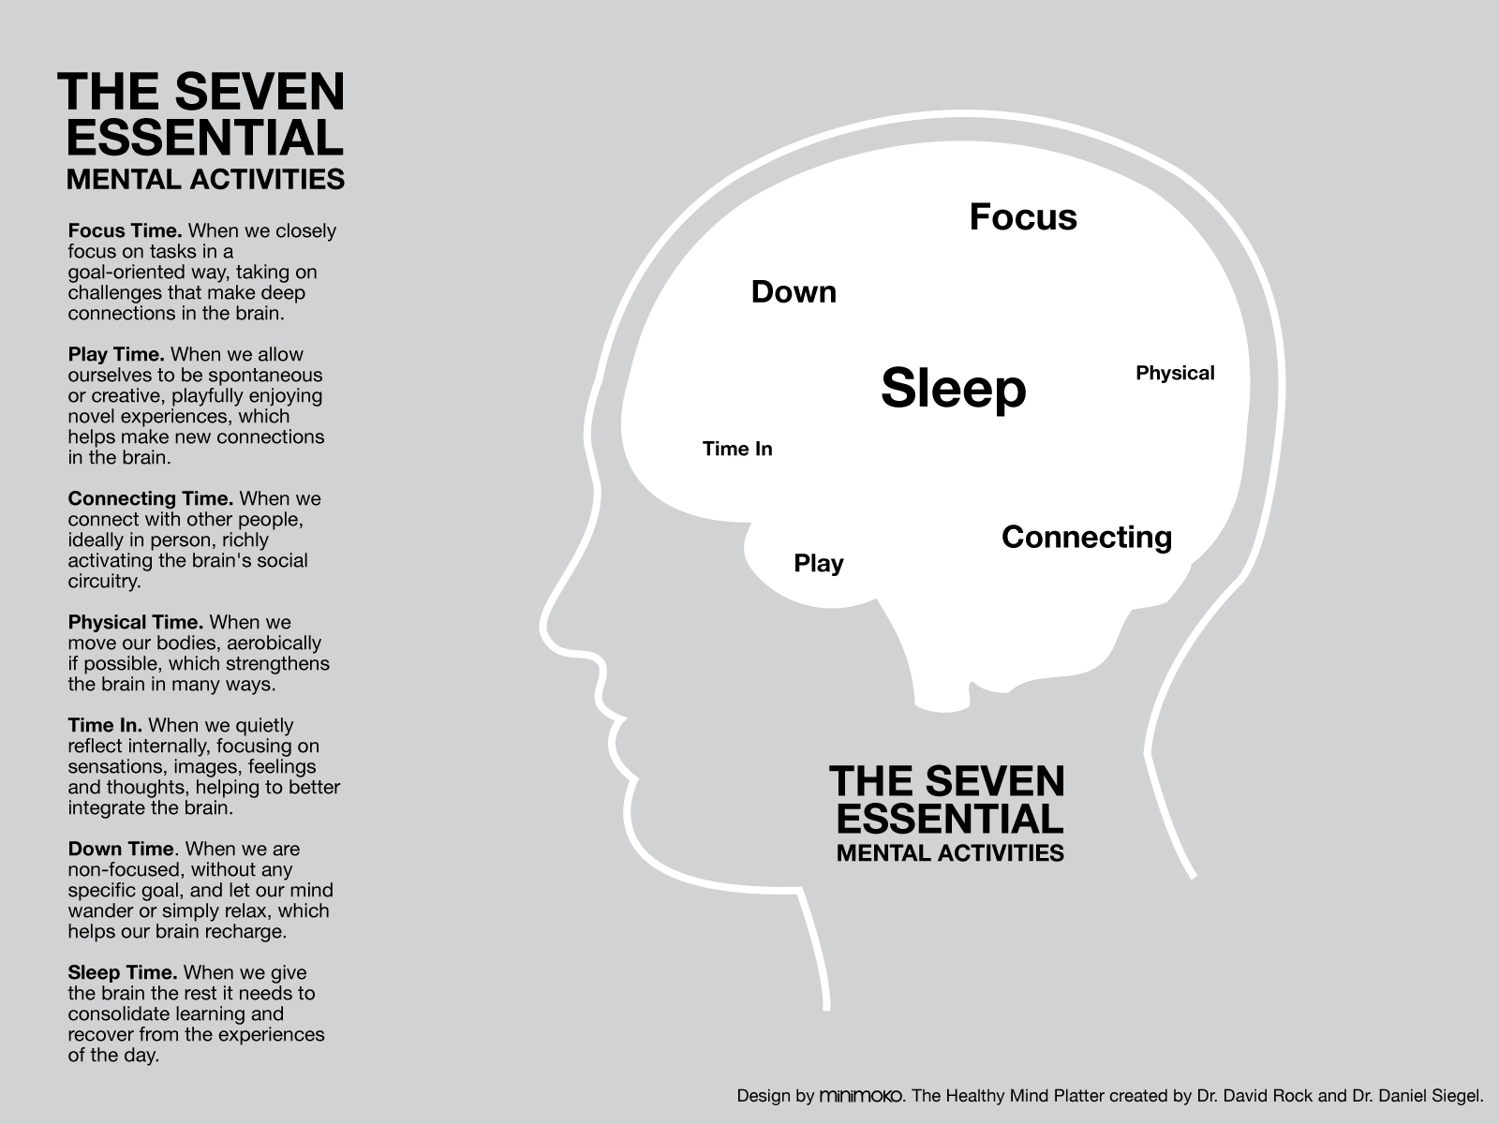

Created by Cheryl L. Erwin, MA, MFT, Certified Positive Discipline Lead Trainer and adapted for teens by Julia Tomes, M.A.T. and Certified Positive Discipline Trainer.

Information compiled from www.commercialfreechildhood.org, American Academy of Pediatrics, www.screenagersmovie.com, and CNN.

