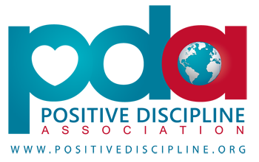
Positive Discipline Parenting Class:
How to Parent with Kindness and Firmness

Research shows that children raised in families which use an authoritative parenting approach grow up to be the healthiest, happiest, and most resilient adults. Children who perceive their parents to be both kind (responsive) and firm (structured) are at a lower risk for all forms of risky behavior once they are adolescents, and they also show improved academic performance. The bottom line is that children and teens who feel a strong connection to their family, school, and community are less likely to misbehave.
Positive Discipline is deeply respectful and encouraging for both children and adults. Focusing on connecting, teaching, and guiding children, it is filled with practical, non-punitive and non-permissive techniques which allow for kind and firm parenting. In this 8 week class you will learn how to encourage your children to be self-motivated, more responsible, and gain greater respect for themselves and others. Participants will also learn about their child’s growing brain and how to best parent each stage from birth to adulthood. This class is for families with children of any and all ages.

Cost: Early Bird Registration by Sunday, February 3rd, $135 individual/$170 couple. After February 3rd, $165 individual/$200 couple.
(Added $5.00 processing fee for credit card payment) Sliding scale available.

**We will be reading one of the books in the Positive Discipline Series by Jane Nelson, Ed.D and others. Please check with Julia to determine which book best meets your parenting needs. Participants can order their copy through me for $12.00.

Dates and Time: Monday Evenings 6:30 – 8:45pm, February 25th – April 29th, 2019
(No Classes 3/25 and 4/8, due to school holidays)

Location: Creative Science School, 1231 SE 92nd Ave, Portland, OR 97216

Registration or further information: Please visit, www.juliatomes.com

Facilitated by: Julia Tomes, M.A.T. Julia has a Masters of Arts in Teaching in elementary and secondary education and is trained in Montessori Ed. for Pre-primary. She has taught grades 5-8 in public schools as well as Montessori Preschool. For the past 9 years she has been a certified Positive Discipline Trainer, working with parents and teachers to build respectful relationships in homes and classrooms. Julia has two teenage children and experiences daily practice using the tools of Positive Discipline.

For further information about Positive Discipline, please visit http://www.positivediscipline.org

